|  |
| --- |
|  |
| **October**  **2019** |
|  |

**Milbrook Elementary School**

We are always on TRACK!

As a Milbrook Mustang:

**T**oday I will:

**R**espect others

**A**ct responsibly

**C**ome prepared

**K**eep safe

|  |
| --- |
|  |
| October 25: PTA Halloween Dance 6 pm  November 8: ½ Day for students. End of 1st Quarter  November 18-22nd:  American Education Week |
|  |

**Principal: Anne Gorman**

**Assistant Principal: Candace Brinkley**

www.milbrookelementary.bcps.org

4300 Crest Heights Road

Baltimore, MD 21215

**T: 410-887-1225**

**F: 410-887-6744**

**A MESSAGE FROM MRS.GORMAN**

As we enter October, we are approaching the mid-quarter mark for students. Interims went home on October 10, 2019. Please make sure to review your child’s grades on Schoology and see if they have any missing assignments that can be completed so they earn credit before the end of the quarter next week.

Fall weather has finally arrived. Please remember to send students in the appropriate outer wear because the students will have daily recess outside, unless it is raining.

October is Attendance Awareness Month. It is very important for students to be at school each day. However, we understand that illness happens, and students need to stay home and get better. Please make sure that if your student is absent that you send a note in when they return to school so all absences can be coded correctly. In addition, please make every effort to have students arrive on time and stay until dismissal. We have had several parents coming in very close to dismissal asking for students to be dismissed. Please be courteous and wait for the official dismissal time. If you have appointments and students need to be picked up early, please send in a note with your child that day. It is very busy during dismissal time and we would ask that no changes in dismissal happen after 3:00 pm so we can ensure a safe and efficient dismissal. Thank you for your help with this matter.

Mrs. Anne Gorman

|  |
| --- |
|  |

|  |
| --- |
|  |
| **Arrival and dismissal procedures**  If you are dropping off or picking up in carpool, please make sure to follow the adults directing and assisting with this task. Please do not park in the crossing walk or reserved spaces. We appreciate your help with keeping our school campus safe for all students.  **VISITORS**  All parents and other visitors entering the school must report to the office through the front doors and sign in. Please make sure that you have a photo ID with you when you report to the office. Each visitor will have their ID scanned by one of the administrative assistants and a photo badge will be issued. Anyone in the school building without a badge should expect to be approached and questioned. We have also reminded staff and students that they are **never** allowed to open any door to visitors. All visitors must be buzzed into the building. These guidelines are designed to assist us in providing a safe and orderly school environment. Our guidelines are intended to ensure the safety and security of the school community, not to limit parent involvement in our school.  **DISMISSAL reminderS**  Parents are asked to assist with dismissal procedures by making certain that children are clear about dismissal plans before they enter school each morning. Last minute changes in plans are often confusing to children. **All changes in transportation plans must be put in writing with the day’s date and sent to the children’s teachers on the morning of the change.** When requesting that a change be made in their children’s dismissal plans, parents will be asked to send in a signed and dated note the day of the change. In the event that a change must be made during the school day, please call the school and let Ms. Fitzgerald know about the change. **Changes made after 3:00 PM cannot be honored by the office.**  After this time, the secretaries are busy contacting children and teachers about the changes called into the office earlier in the day.  **CELEBRATING BIRTHDAYS**  • We no longer allow food to be brought in as a birthday treat, unless this is purchased through our cafeteria. They do provide this with several weeks’ notice. Please contact Ms. Bauer in the cafeteria for further information. If you do not utilize this service from our cafeteria, you are welcome to bring in a small token such as a pencil or fun eraser for the birthday child to distribute to the class.  Birthday party invitations may only be distributed through school **if every student in your child’s class is being invited**. We never want to hurt anyone’s feelings.  academic,apples,communications,education,instructors,occupations,people,teachers,women,food  Counselor's Corner  **Magnet School Information**  Don’t forget, the Magnet School applications are due by **November 15, 20189**. There will be an information meeting at Milford Mill on October 3, 2019 at 6:30 for those interested in learning more about Magnet Schools. If you have any questions, feel free to contact Ms. Uhrin at [juhrin@bcps.org](mailto:juhrin@bcps.org). | |

**Supper Club/Food Bank**



Supper Club starts Tuesday, September 10 and we would love to know in advance which kids would like to sign up, even though drop-in students are welcome. You can RSVP your child’s name to Mrs. McLean via email: [mmclean2@bcps.org](mailto:mmclean2@bcps.org).

In addition, we expect our Food Bank to begin in October and more information will follow.

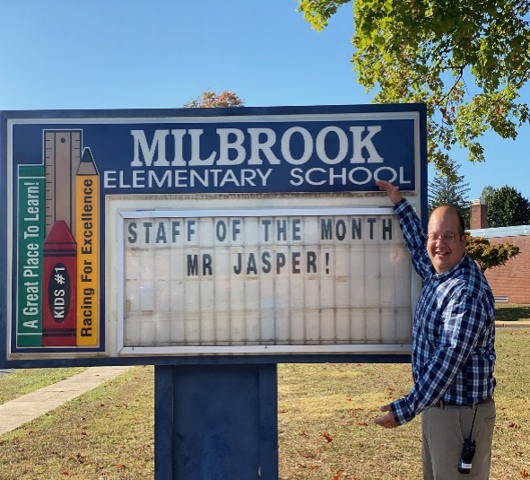

Staff of the Month: October

Mr. Jasper- Grade 5

Hello Milbrook, Elementary School,  
  
                My name is Stephen Jasper and I am excited to be the Teacher of the Month at Milbrook Elementary School!

 I have been working in Baltimore County for 20 years in a variety of roles.  I have worked as a fifth grade teacher, third grade teacher, fourth grade teacher, GT teacher, Math Resource, Technology Integration teacher (in the computer lab), and a STAT teacher. None of those roles have been more rewarding (or fun) then working as a fifth-grade teacher at Milbrook. I enjoy working alongside so many wonderful and hardworking staff members and inspiring administrators. Furthermore, as a MES teacher I get the chance to teach and learn from so many amazing and talented students.

Each day I am encouraged by all the wonderful things that occur at Milbrook. I am grateful that the students, staff and Milbrook community members are driven to make the world a better place and make real change. For that, I am so grateful to see their lights shine! A big thank you to everyone who has supported me over the years at Milbrook.

A few things about me…

First, I love spending time with my family! I have a wonderfully talented wife who has an amazing eye for art. I enjoy watching my two children draw, play sports, and sing. I enjoy watching baseball (Go Yankees), and football (Go Giants… and Ravens). I enjoy walking on trails (Green School), working with computers (TV studio), and of course watching a good Science Fiction movie or two😊